**Project Design Phase-II**

**Technology Stack (Architecture & Stack)**

|  |  |
| --- | --- |
| Date | 15 October 2022 |
| Team ID | PNT2022TMID48082 |
| Project Name | Project - **Smart waste management system for metropolitan cities** |
| Maximum Marks | 4 Marks |

**Technical Architecture:**

The Deliverable shall include the architectural diagram as below and the information as per the table1 & table 2

**Example: Order processing during pandemics for offline mode**

**Reference: <https://developer.ibm.com/patterns/ai-powered-backend-system-for-order-processing-during-pandemics/>**

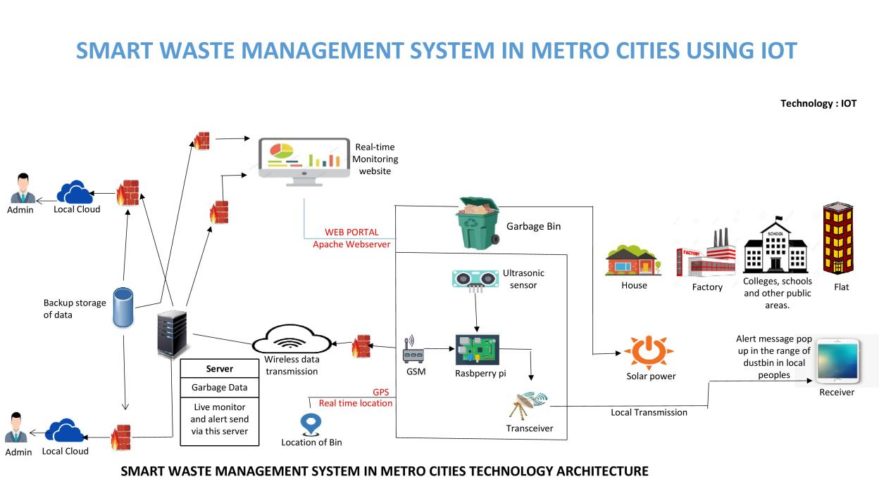

Guidelines:

1. Include all the processes (As an application logic / Technology Block)
2. Provide infrastructural demarcation (Local / Cloud)
3. Indicate external interfaces (third party API’s etc.)
4. Indicate Data Storage components / services
5. Indicate interface to machine learning models (if applicable)

**Table-1 : Components & Technologies:**

|  |  |  |  |
| --- | --- | --- | --- |
| **S.No** | **Component** | **Description** | **Technology** |
| 1. | User Interface | User had to register and view the other device’s location e.g.Web UI, Mobile App etc. | HTML, CSS, JavaScript |
| 2. | IoT Application Logic-1 | Proximity and Weight sensors, Raspberry PI, Xbee module were implemented to detect the garbage level of the bin | Python |
| 3. | IoT Application Logic-2 | Backup & recovery. Comprehensive data resilience for physical and virtual servers | IBM Watson Assistant |
| 4. | IoT Application Logic-3 | If level of bin is full it will be notified to admin using this device by tracking & converting using STT | IBM Watson STT Service |
| 5. | Database | Data Type can be any format such as arbitrary binary data, text.User-defined blob of data sent from Cloud IoT Core to a device etc. | MySQL, MongoDB, PostgreSQL, Redis |
| 6. | Cloud Database | Users install tracking software on a cloud infrastructure to implement the database. | IBM DB2, IBM Cloudant etc. |
| 7. | File Storage | Files will be labeled with what they contain and how long they should be kept | IBM Block Storage or Local Filesystem |
| 8. | External API-1 | Purpose of External API used in the device is to use the internet for communicating and conducting allotted operations efficiently | Aadhar API, etc. |
| 9. | External API-2 | External API used in the device to expose data that enables those devices to transmit data to your device/mobile, acting as a data interface. | City Geo-Location Lookup API etc. |
| 10. | Infrastructure (Server / Cloud) | Application Deployment on Local System / Cloud Local  Server Configuration:Wearable tech device Cloud Server Configuration: Massive network that supports IoT devices and applications | Local, Cloud Foundry, Kubernetes,Underlying Infrastructure etc. |

**Table-2: Application Characteristics:**

| **S.No** | **Characteristics** | **Description** | **Technology** |
| --- | --- | --- | --- |
|  | Open-Source Frameworks | Device that removes much of the manual work needed to write and configure code. It provides rapid development, is easy to set up and has a strong support base | Open remote |
|  | Security Implementations | use data gathered by smart devices to improve infrastructure, public utilities, and services. Such devices can be connected sensors, lights, meters, waste bins, and air quality monitoring systems. | SHA-256, Encryptions, IAM Controls, OWASP etc. |
|  | Scalable Architecture | The way the system was designed, each sensor is responsible for a specific area of the waste-bin and there is no overlap between areas of various sensors. | Automated Bootstrapping |
|  | Availability | optimize resource allocation, reduce running costs, and increase the sustainability of waste services. | Ultrasonic sensor,GPS,GSM,Raspberry pi microprocessor |
|  | Performance | A reduction in the number of waste collections, resulting in less manpower, emissions, fuel use and traffic congestion. | Sigfox, NBiot, LoRa, GPRS |

**References:**

**<https://c4model.com/>**

**<https://developer.ibm.com/patterns/online-order-processing-system-during-pandemic/>**

**<https://www.ibm.com/cloud/architecture>**

**<https://aws.amazon.com/architecture>**

**<https://medium.com/the-internal-startup/how-to-draw-useful-technical-architecture-diagrams-2d20c9fda90d>**